Packet Tracer – Skills Integration Challenge - OSPF

**Note**: This activity and the similar **Packet Tracer - Skills Integration Challenge - EIGRP** activity are meant as resources for you to determine what skills you may not have yet mastered from the previous courses. Refer to your notes and previous content if you need assistance. But it may be fun initially to see just how much you retained.

1. Topology

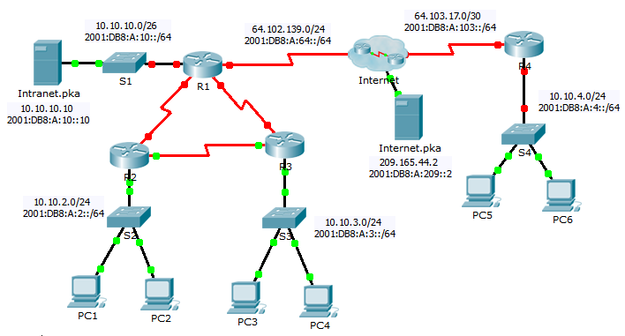

1. Addressing Table

|  |  |  |  |  |
| --- | --- | --- | --- | --- |
| Device | Interface | IPv4 Address | Subnet Mask | Default Gateway |
| IPv6 Address/Prefix | |
| R1 | G0/0 | 10.10.10.1 | 255.255.255.192 | N/A |
| 2001:DB8:A:10::1/64 | | N/A |
| S0/0/0 | 64.102.139.2 | 255.255.255.0 | N/A |
| 2001:DB8:A:64::2/64 | | N/A |
| S0/0/1 | 10.10.1.1 | 255.255.255.252 | N/A |
| 2001:DB8:B:1::1/64 | | N/A |
| S0/1/0 | 10.10.1.5 | 255.255.255.252 | N/A |
| 2001:DB8:B:2::1/64 | | N/A |
| Link-Local | FE80::1 | | N/A |
| R2 | G0/0 | 10.10.2.1 | 255.255.255.0 | N/A |
| 2001:DB8:A:2::1/64 | | N/A |
| S0/0/0 | 10.10.1.9 | 255.255.255.252 | N/A |
| 2001:DB8:B:3::1/64 | | N/A |
| S0/0/1 | 10.10.1.2 | 255.255.255.252 | N/A |
| 2001:DB8:B:1::2/64 | | N/A |
| Link-Local | FE80::2 | | N/A |
| R3 | G0/0 | 10.10.3.1 | 255.255.255.0 | N/A |
| 2001:DB8:A:3::1/64 | | N/A |
| S0/0/0 | 10.10.1.10 | 255.255.255.252 | N/A |
| 2001:DB8:B:3::2/64 | | N/A |
| S0/0/1 | 10.10.1.6 | 255.255.255.252 | N/A |
| 2001:DB8:B:2::2/64 | | N/A |
| Link-Local | FE80::3 | | N/A |
| R4 | G0/0 | 10.10.4.1 | 255.255.255.0 | N/A |
| 2001:DB8:A:4::1/64 | | N/A |
| S0/0/1 | 64.103.17.2 | 255.255.255.252 | N/A |
| 2001:DB8:A:103::2/64 | | N/A |
| Link-Local | FE80::4 | | N/A |
| Internet | NIC | 209.165.44.2 | 255.255.255.252 | 209.165.44.1 |
| 2001:DB8:A:209::2/64 | | FE80::5 |
| Intranet | NIC | 10.10.10.10 | 255.255.255.192 | 10.10.10.1 |
| 2001:DB8:A:10::10/64 | | FE80::1 |
| PC1 - PC6 | NIC | DHCP assigned | | DHCP assigned |
| Auto Config | | Auto Config |

1. Scenario

Your business has just expanded into a different town and needs to expand its presence across the Internet. You are tasked with completing the upgrades to the enterprise network, which includes dual-stacked IPv4 and IPv6, and a variety of addressing and routing technologies.

Requirements

**Note**:Although not required, adding additional labeling to the topology may help you as you proceed. All names and passwords are case-sensitive.

**Basic Device Configuration**

* Configure the following on **R1** and **R4**.
  1. Set the device names to match the **Addressing Table**.
  2. Set **cisco** as the encrypted privileged EXEC mode password.
  3. Set a banner MOTD which includes the word **warn**.
  4. Set the IPv4 and IPv6 addresses according to the **Addressing Table**.
  5. Assign the link local address to each interface.

**SSH**

* Configure SSH on **R4**.
  1. Set a domain name of **R4**.
  2. Create a user of **admin** with an encrypted password of **cisco**.
  3. Create a 2,048-bit RSA key.
  4. Configure all vty lines to use SSH and a local login.

**DHCPv4**

* Configure **R4** to act as a DHCP server for its LAN.
  1. Create a DHCP pool using the name **R4**.
  2. Assign the appropriate addressing information to the pool including the 209.165.44.2 as the DNS server.
  3. Prevent the address used by the router from being distributed to end devices.

**NAT**

* Configure NAT/PAT on **R4** so that all devices on the LAN use the IP address on the Serial 0/0/1 to access the Internet.
  1. Use a single statement in access list **1** to define the addresses that will participate in NAT. Allow only the 10.10.4.0/24 address space.
  2. Enable NAT/PAT using the access list.
  3. Configure the appropriate interfaces as NAT inside or outside.
* Configure PAT on **R1**.
  1. Use a single statement in access list **1** to define the addresses that will participate in NAT. Allow only the 10.10.0.0/16 address space.
  2. Define a pool named **R1** to use all four addresses in the 64.102.139.4/30 address space.
  3. Assign access list **1** to the **R1** pool.
  4. Configure the appropriate interfaces as NAT inside or outside.
* Configure static NAT on **R1** for remote access to **Intranet.pka** server.
  1. Use a static NAT statement to redirect TCP port 80 traffic from 64.102.139.2 to 10.10.10.10.
  2. Use a static NAT statement to redirect TCP port 443 traffic from 64.102.139.2 to 10.10.10.10.

**Default Routing**

* On **R1**, configure an IPv4 default route using the next-hop IP address 64.102.139.1.
* On **R1**, configure an IPv6 default route using the exit interface.
* On **R4**, configure an IPv4 and IPv6 default route using the exit interface.

**OSPF Routing**

* Configure OSPFv2 area 0 on **R1**.
  1. Use process ID 1.
  2. Advertise directly connected networks. Do not include the link to the Internet.
  3. Prevent routing updates from being sent across the LAN interfaces.
  4. Propagate the default route.
* Configure OSPFv3 area 0 on **R1**.
  1. Use process ID 1.
  2. Assign 1.1.1.1 as the router ID.
  3. Prevent routing updates from being sent across the LAN interfaces.
  4. Complete any required OSPFv3 or IPv6 routing configurations.

**Verify Connectivity**

* Configure **PC5** and **PC6** to use DHCP for IPv4 and Autoconfig for IPv6.
* Verify web access to **Internet.pka** and **Intranet.pka** from each six PCs. Be sure to test both IPv4 and IPv6. Pings are not forwarded from PC5 and PC6 to **Intranet.pka**.